**Project Documentation**

**FITFLEX: YOUR PERSONAL FITNESS COMPANION**

# 1. Introduction

* **Project Title:** Fitflex: Your Personal Fitness Companion
* **Team ID**: NM2025TMID36488
* **Team Leader:** Rathipriya P & [24csrathipriya077@gmail.com](mailto:24csrathipriya077@gmail.com)
* **Team Members:**
  + Rathika K & [24csrathika076@gmail.com](mailto:24csrathika076@gmail.com)
  + Vaishnavi S & [24csvaishnavi106@gmail.com](mailto:24csvaishnavi106@gmail.com)
  + Sujithra G & [24cssujithra100@gmail.com](mailto:24cssujithra100@gmail.com)

# 2. Project Overview

* **Purpose:** Fitflex is a personalized fitness companion app designed to help users track workouts, monitor nutrition , set health goals ,and stay motivated through real- time progess tracking and interactive features.
* **Features:**
  + Personlized workout plans
  + Nutrition and calorie tracking
  + Real- time progess dashboard
  + Goal setting and remainers

# 3. Architecture

* **Frontend:** React.js with Bootstrap and Material UI
* **Backend:** Node.js and Express.js managing server logic and API endpoints
* **Database:** MongoDB stores user profile, workout data, project information, applications, and chat messages

# 4. Setup Instructions

* **Prerequisites:**
  + Node.js
  + MongoDB
  + Git
  + React.js
  + Express.js
  + **–** Mongoose
  + **–** Visual Studio Code
* **Installation Steps:**

# Clone the repository git clone

# Install client dependencies cd client npm install

# Install server dependencies cd

../server npm install

# 5. Folder Structure

SB-Works/

|-- client/ # React frontend

|__components/ L__ pages/

|__ server/ # Node.js backend

|__routes/

|__ models/

|__ controllers/

# 6. Running the Application

* **Frontend:**

cd client

npm start • **Backend:**

cd server npm start

* **Access:** Visit http://localhost:3000

# 7. API Documentation

* **User:**
  + /api/user/register
  + /api/user/login
* **Projects:**
  + /api/projects/create
  + /api/projects/:id
  + • **Applications:** /api/apply
* **Chats:**
  + /api/chat/send

**–** /api/chat/:userId

# 8. Authentication

* JWT-based authentication for secure login
* Middleware protects private routes
* Refresh token mechanism for extended sessions
* Planned integration of Two- Factor Authentication(2FA)

# 9. User Interface

* Landing Page
* Freelancer Dashboard
* Admin Panel
* Project Details Page
* User Dashborad

# 10. Testing

* Manual testing during milestones
* Tools: Postman, Chrome Dev Tools

**EXTENDING TESTING STRATEGY**

* Mobile-responsive design
* Dark and light theme options
* Accessibility features (contrast, font size adjustment)
* Automated testing using Selenium

• Continuous integration with GitHub Actions

1. **Screenshots or Demo**

• Demo video planned for presentation

• Sample user dashboard and progress charts

We have added some screenshots from our project FITFLEX:YOUR PERSONAL FITNESS COMPANION

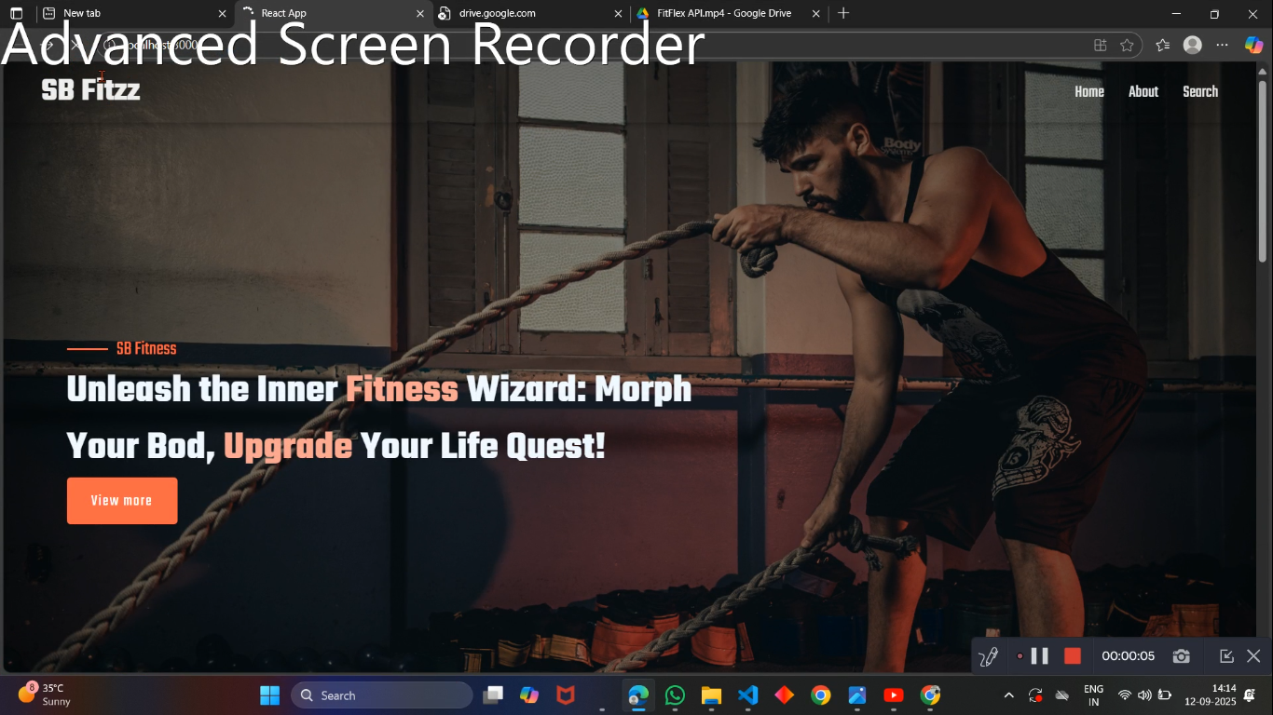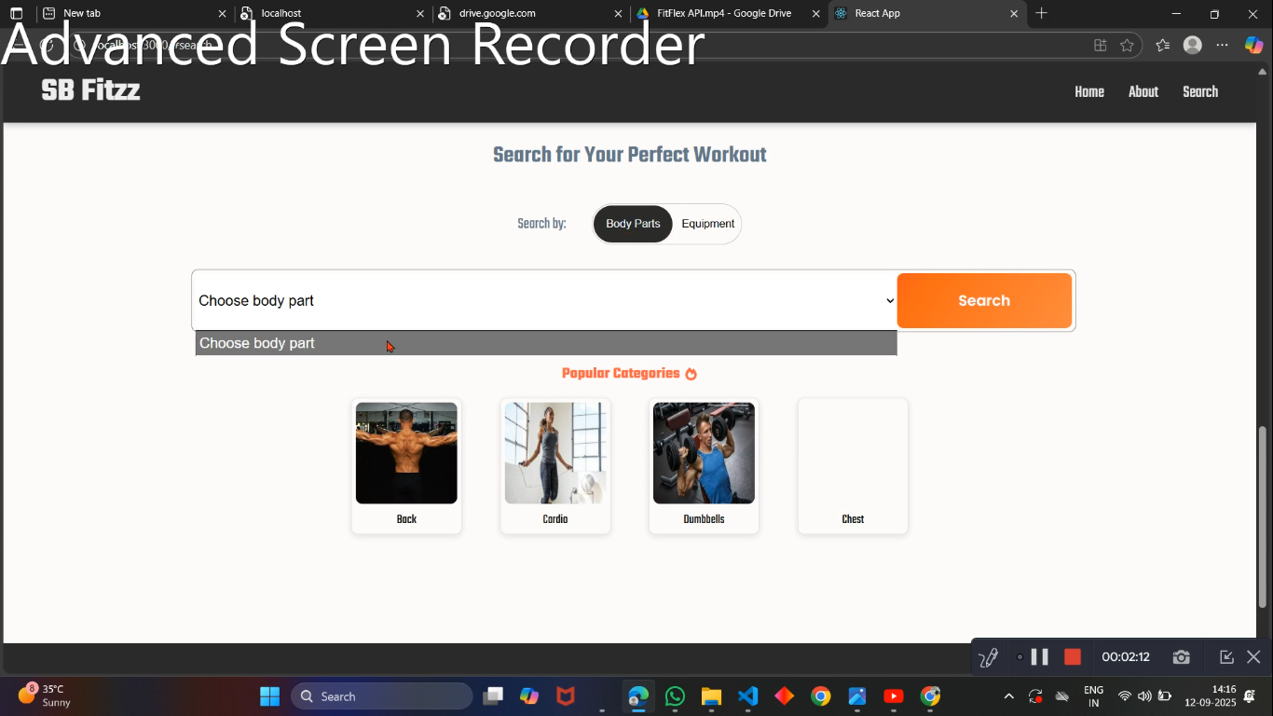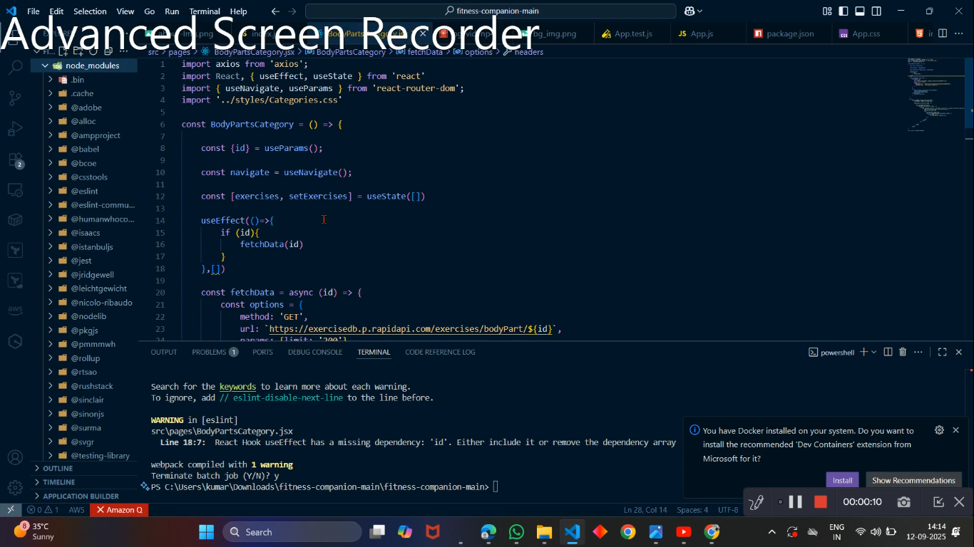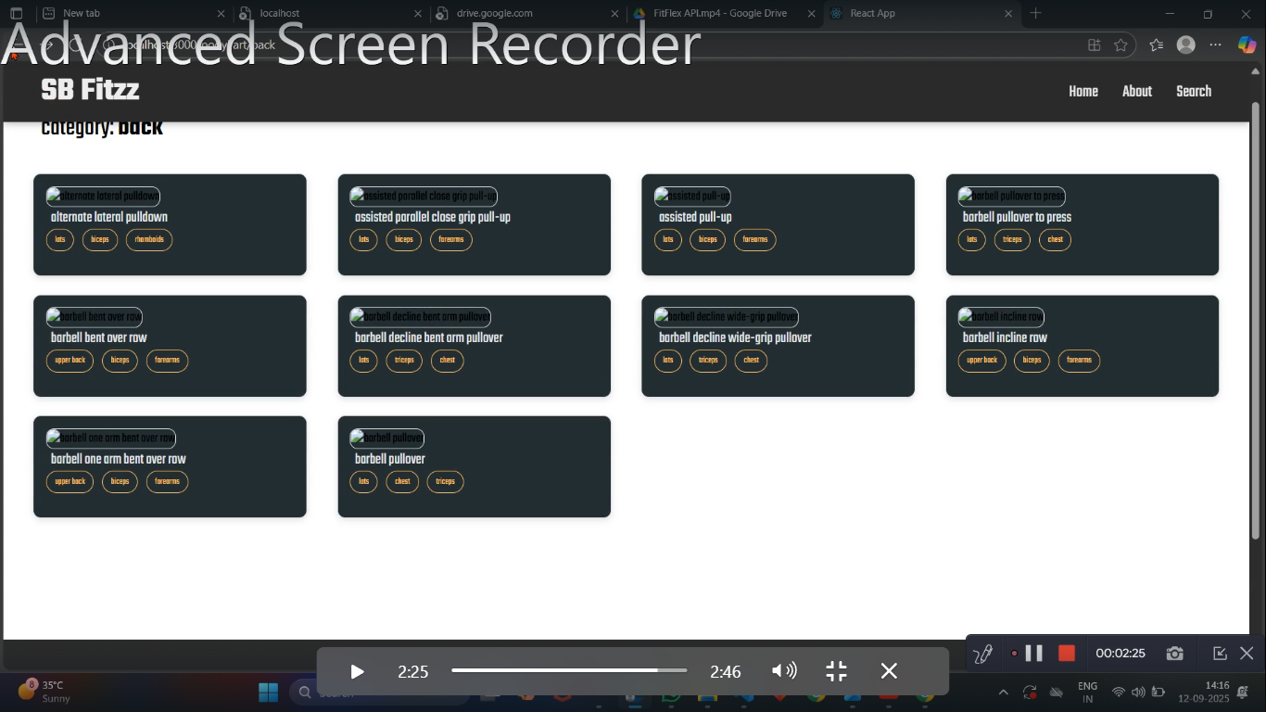

1. **Known Issues**

• Mobile responsiveness under development

• Limited third-party fitness device integration

• Performance issues on low-end devices

• API response time may increase under heavy load

• Limited offline access in current version

**13. Future Enhancements**

# • Integration with wearable fitness trackers (Fitbit, Apple Watch, etc.)

# • AI-based workout & meal recommendations

# • Social media sharing of fitness progress

# • Voice assistant for workout guidL AAAAAL HGDance

• Offline access for logging workouts

• Cloud-based sync across multiple devices

1. **Conclusion**

FitFlex is designed to be an all-in-one fitness companion for personal use or small fitness groups. It focuses on simplicity, personalization, and motivation to help users stay on track toward their fitness goals.